Linear Regression HOMEWORK
The following figure shows three data points and the best fit line (linear regression line)
y = 3x + 2.
The x-coordinate, or "x", is our independent variable and the y-coordinate, or "y", is our dependent variable.
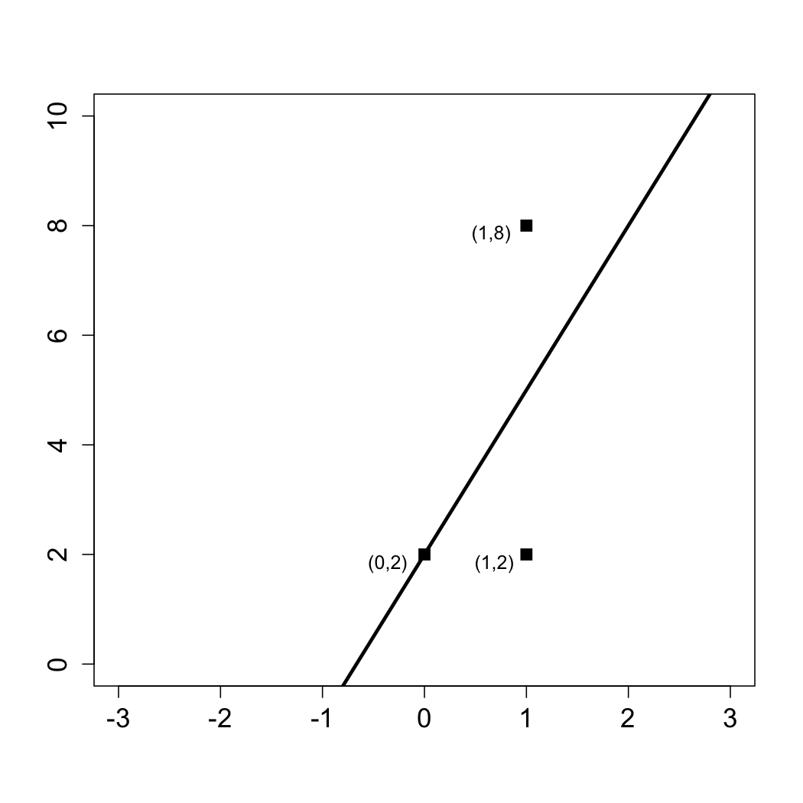

Answer the following questions using this figure.
- What is the baseline prediction?
- What is the Sum of Squared Errors (SSE)?
- What is the Total Sum of Squares (SST)?
- What is the R² of the model?

